French Beaded Spring Pansy
By Briana Olson
Materials and Tools
- Size 11 seed beads in 2-6 colors
- 26g wire
- Optional bead mat
- Wire cutters
- Needle nose pilers

Petal Instructions
For each petal and leaf cut 25’’ of wire, form a stopper loop at one end and string center beads. These will form the very center petal.
Create space from stopper to the beads about three finger widths.
Below the center beads create a loop 2-3 finger lengths and twist wire below the beads.
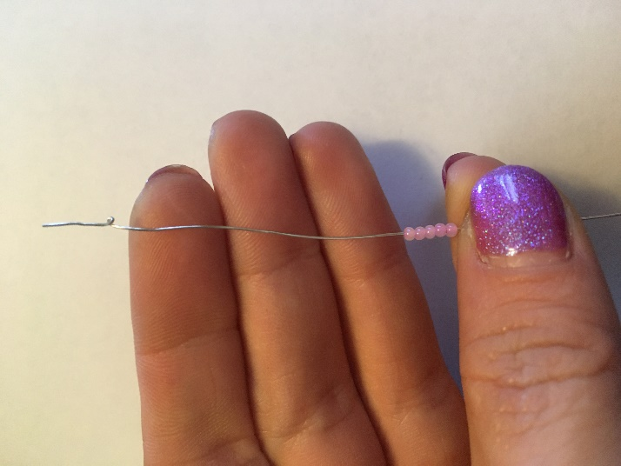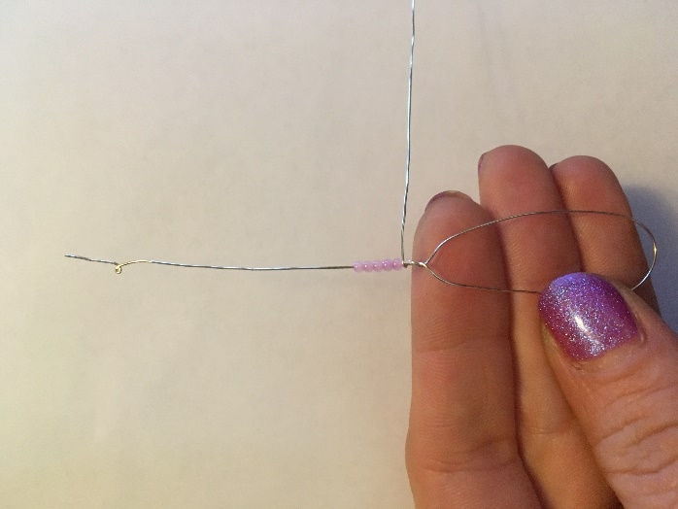
Next string each line of beads then loop around wire above or below the center beads in an outward spiral.
When you finish each petal or leaf take the wire at the top and loop it around the last row of beads then twist remaining wire at bottom around loop making a stem. Trim off excess wire.
* Bead counts below are a suggestion and can change with bead manufactures. Adjust as necessary *
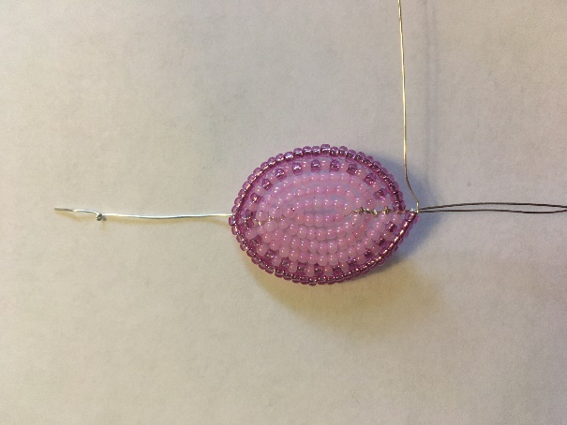
Upper petals - make two, use two colors
- 6 main color
- 7 main color
- 9 main color
- 10 main color
- 13 main color
- 15 main color
- 16 main color
- 20 main and edge color alternating
- 22 main and edge color alternating
- 25 edge color
- 27 edge color
Middle petals - make two, use three colors
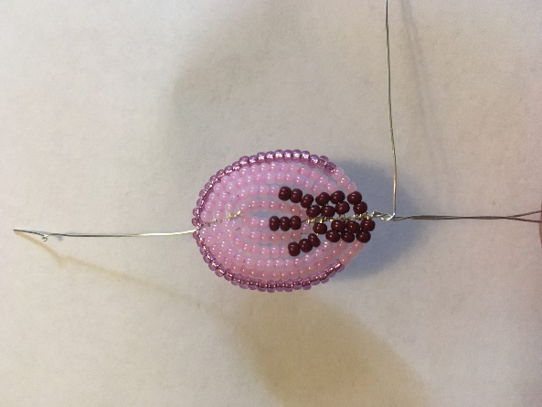
- 3 main color, 3 center line color
- 7 main color
- 8 main color
- 4 center line color, 6 main color
- 8 main color, 4 center line color
- 2 center line color, 13 main color
- 14 main color, 2 center line color
- 2 center line color, 16 main color
- 18 main color, 2 center line color
- 2 center line color, 3 main color, 20 edge color
- 18 edge color, 3 main color, 2 center edge color
Lower Petal - make one, use 5 colors
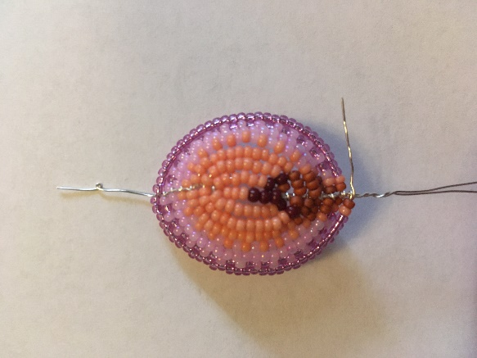
- 3 accent color, 2 center line color
- 1 center line color, 6 accent color
- 8 accent color, 1 center line color
- 1 accent shadow color, 1 center line color, 10 accent color
- 12 accent color, 1 center line color, 1 accent shadow color
- 3 accent shadow color, 13 accent color
- 15 accent color, 3accent shadow color
- 3 accent shadow color, 19 accent color and main color
alternating
- 19 accent color and main color alternating, 3 accent
shadow color
- 2 accent shadow color, 1 accent color, 20 main color
- 21 main color, 1 accent color, 2 accent shadow color
- 1 accent shadow color, 1 accent color, 25 main color and edge color alternating
- 26 main color and edge color alternating, 1 accent color, 1 accent shadow color
- 1 accent shadow, 1 accent color, 29 edge color
- 31 edge color, 1 accent color, 1 accent shadow color
Leaf - make one, use one color
- 6 leaf and stem color
- 7 leaf and stem color
- 8 leaf and stem color
- 10 leaf and stem color
- 12 leaf and stem color
- 15 leaf and stem color
- 16 leaf and stem color
- 19 leaf and stem color
- 20 leaf and stem color
- 22 leaf and stem color
- 23 leaf and stem color

Finishing
Assemble flower by gathering petals keeping the top petals behind the middle petals and the lower petal on top of middle petals.
Twist stem wires tightly creating a thick smooth stem add in leaf twisting to keep secure.
Cut a 25’’ piece of 26g wire and twist around the base of one petal. String leaf and stem colored beads and wrap around stem wires from top to bottom.
Loop end of wire around the loop part of the very bottom of stem, then hide remaining wire between the rows of beads above.

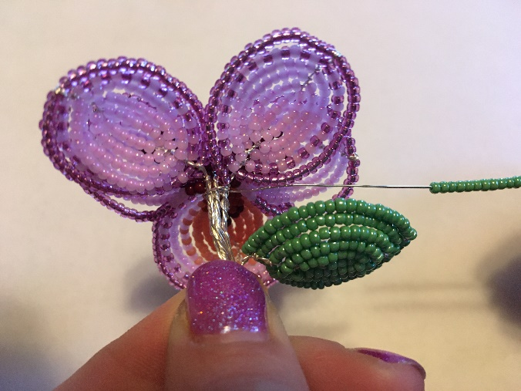
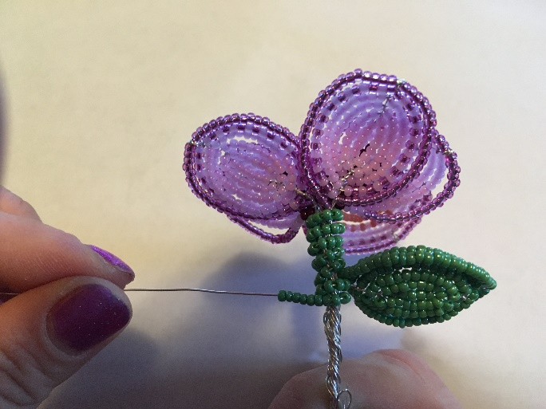

Slightly shape each petal with extra definition on the lower petal.
You have now made a flower and using this technique you can make other flowers as well, enjoy!

